Project Planning Phase
Project Planning Template
Date | 09 September 2026
Student Name | Jetti Harika
Project Name | Automated Network Request Management in ServiceNow

Maximum Marks

Product Backlog, Sprint Schedule and Estimation
Sprint | Functional Requirement (Epic) | User Story / Task | Story Points | Priority | Student Name
Sprint-1 | Foundation | Define business objectives, functional scope, stakeholder mapping and execution roadmap. | 6 | High | Jetti Harika
Sprint-2 | Backend Development | Design data architecture, create the custom network request table, and configure the Approval Request relationship on sysapprovals. | 6 | High | Jetti Harika
Sprint-3 | UI/UX | Design the catalog interface, configure catalog variables, define navigation flow, and configure UI Policies. | 6 | High | Jetti Harika
Sprint-4 | Validation | Configure Flow Designer automation, access control, QA testing and data integrity checks. | 2 | High | Jetti Harika
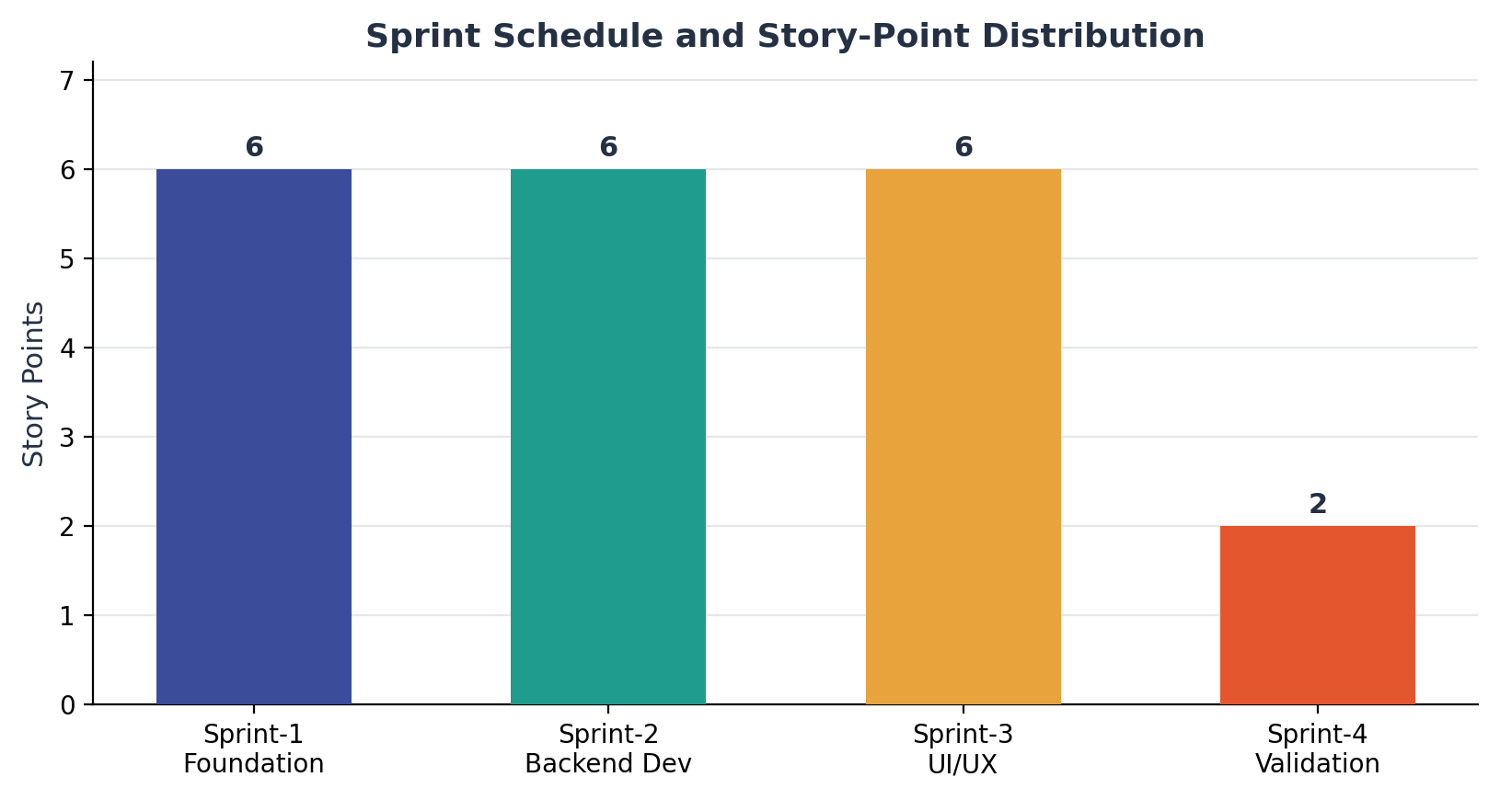
Figure 1: Sprint schedule and story-point representation.

Project Tracker
Work Item | Status | Validation
Business objectives & scope | Completed | Objectives, functional scope and stakeholder mapping documented.
Data architecture | Completed | Custom network request table designed with standard + custom fields.
Approval relationship | Completed | Approval Request relationship created against the sysapprovals table.
Catalog item & variables | Completed | Network Request catalog item configured with ordered variables (100–300+).
UI Policies | Completed | Conditional fields configured for device type and connection type scenarios.
Flow Designer automation | Completed | Get Catalog Variables, Create Record, Ask for Approval, Send Email, Update Record configured.
Access control | Completed | Role-based access configured to restrict visibility to authorized users.
Testing | Completed | Navigation, form behavior, approvals and data integrity validated.

